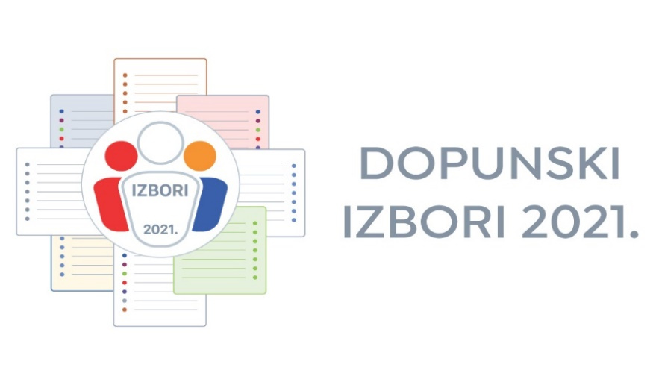
Information for international observers regarding observing additional local elections that will be held on 3 October 2021
According to the Obligatory instructions for observers for local elections in the Republic of Croatia, international observers have right to observe method of election, election procedure and work of electoral bodies.
International observers are representatives from the international organizations engaged in the Republic of Croatia, representatives of diplomatic-consular missions located in the Republic of Croatia, representatives of international electoral associations and representatives of electoral commissions from other countries.
Application form for observing local elections in Croatia is available on the web site of the State Electoral Commission of the Republic of Croatia (hereinafter: Commission).
Approval for election observation will be delivered without delay to the international organization or to international observer itself to the address indicated in the application form, by the Commission.
The Commission will issue an official ID card for every international observer who has approval for election observation.
For more information, please contact the State Electoral Commission of the Republic of Croatia:
Phone: ++ 385 1 2100 600
++ 385 1 2100 601
E-mail: dip@izbori.hr

THE STATE ELECTORAL COMMISSION
OF THE REPUBLIC OF CROATIA

